EMOTIONAL BASED MUSIC PLAYER USING FACE DETECTION

A project report submitted in partial fulfillment of the requirements for
the award of the degree of

BACHELOR OF COMPUTER APPLICATIONS

Submitted by
R.MOUNIKA (22UCA135)

E.JANA (22UCA092)

V.J.HARINISHREE (22UCA082)
V.MADHANESH (22UCA122)
S.BHUVANESWARAN (22UCA029)
S.SANTHOSHKUMAR (22UCA192)

Under the Guidance of

Mrs. P.CHITRA MCA., M.Phil.,


K.S.RANGASAMY COLLEGE OF ARTS AND SCIENC(AUTONOMOUS)
NAAC Accredited with ‘A’ and an ISO Certified Institution affiliated to
Periyar University, Salem,
Included under 2(f) & 12B of UGC Act, 1956
K.S.R. Kalvi Nagar, Tiruchengode 637 215
Namakkal District, Tamil Nadu, India
MAY 2025
K.S.RANGASAMY COLLEGE OF ARTS AND SCIENC(AUTONOMOUS)
NAAC Accredited with ‘A’ and an ISO Certified Institution affiliated to
Periyar University, Salem,
Included under 2(f) & 12B of UGC Act, 1956

K.S.R. Kalvi Nagar, Tiruchengode 637 215
Namakkal District, Tamil Nadu, India

EMOTIONAL BASED MUSIC PLAYER USING FACE DETECTION

Bonafide work done by
R.MOUNIKA (22UCA135)

E.JANA (22UCA092)

V.J.HARINISHREE (22UCA082)
V.MADHANESH (22UCA122)
S.BHUVANESWARAN (22UCA029)
S.SANTHOSHKUMAR (22UCA192)

A project report submitted in partial fulfillment of the requirements for the award of
the degree of
BACHELOR OF COMPUTER APPLICATIONS

Submitted for the Viva-Voce Examination held on __________________

Signature of the Guide Head of the Department

Internal Examiner External Examiner

DECLARATION

DECLARATION

We hereby declare that this project entitled “EMOTIONAL BASED MUSIC PLAYER USING FACE DETECTION” submitted to K.S.Rangasamy College of Arts and Science (Autonomous), Tiruchengode 637 215, Periyar University, Salem is a record of original work done by ourself under the guidance of Mrs. P. CHITRA, MCA., M.Phil., Assistant Professor, Department of Computer Applications, K.S.Rangasamy College of Arts and Science (Autonomous), Tiruchengode and this project work has not formed the basis for the award of any Degree / Diploma / Associateship / Fellowship or similar title to any candidate of any university.

Place: Tiruchengode Signature of the Candidate
Date:
R.MOUNIKA (22UCA135)-

E.JANA (22UCA092)-
V.J.HARINISHREE (22UCA082)-
V.MADHANESH (22UCA122)-
S.BHUVANESWARAN (22UCA029)-
S.SANTHOSHKUMAR (22UCA192)-

ACKNOWLEDGEMENT

ACKNOWLEDGEMENT

We are very much grateful to the almighty god and our parents who helped us all the way and who have modeled us into what we are today.
We acknowledge our sincere thanks to our beloved founder Theivathiru Lion

Dr. K. S. Rangasamy MJF, our Chairman, Mr. R. Srinivasan , our Vice Chairman
Mr. K.S. Sachin and our Principal Dr. M. Prasanna Rajeshkumar, M.Sc.,Ph.D., K. S. Rangasamy College of Arts and Science (Autonomous) for their immense help in carrying out the project.
We pay our gratitude to respectable Head of the Department
Dr. J. Ramesh, M.C.A., M.Phil., Ph.D., for enabling us to make use of the laboratory and library facility liberally which helped us a long way in carrying out our project work successfully.
We extend our sincere thanks to our Project Coordinator,
Mrs. S.Samundeeswari, MSc,. M.Phil., (Ph.D)., Assistant Professor, Department of Computer Applications, who has given valuable suggestions in reviews and coordinated us to complete this project.
We extend our sincere thanks to Mrs. P.Chitra, MCA., M.Phil., Assistant Professor, Department of Computer Applications, who guided us in the right way to finish our project without any trouble.
We sincerely thank all the staff members of the Department of Computer Applications
for their kind co-operation during the period of our project work.

CONTENTS

S.NO | TITLE | PAGE.NO
 | SYNOPIS | 1
1 | INTRODUCTION | 2
 | 1.1 About the organization | 2
 | 1.2 Project Description | 2
2 | SYSTEM ANALYSIS | 4
 | 2.1 Existing System | 4
 | 2.1.1 Drawbacks of existing system | 4
 | 2.2 Proposed System | 4
 | 2.2.1 Advantages of proposed system | 6
 | 2.3 System Requirement and Specifications | 7
 | 2.3.1 Hardware Requirements | 7
 | 2.3.2 Software Requirements | 7
 | 2.3.3 About the Software | 8
3 | SYSTEM DESIGN AND DEVELOPMENT | 18
 | 3.1 System Flow Diagram | 19
 | 3.2 Data Flow Diagram | 19
 | 3.3 Module Description | 23
 | 3.4 Input Design(Module wise) | 25
 | 3.5 Output Design(Module wise) | 26
 | 3.6 Database Design(Module wise) | 28
 | 3.7 Code Design(Source code) | 30
 | 3.8 Report Design(Module wise) | 43
4 | TESTING AND IMPLEMENTATION | 46
 | 4.1 Testing Techniques | 46
 | 4.2 System Implementation | 48
5 | CONCLUSION | 50
6 | FUTURE ENHANCEMENT | 52
 | BIBLIOGRAPHY | 54
7 | 7.1 Textbook references | 54
 | 7.2 Web references | 54
8 | APPENDIX | 57
 | 8.1 Screen Layouts | 57

SYNOPSIS

SYNOPIS

The Emotional-Based Music Player is an intelligent application designed to enhance user experience by playing music that matches the user's current emotional state. This innovative project uses Python for backend processing, OpenCV for real-time face detection, and a pretrained machine learning model to analyze facial expressions and identify emotions such as happiness, sadness, anger, surprise, or neutrality.
The front-end interface, developed using HTML and CSS, offers a clean, interactive, and user-friendly design for seamless interaction. When the user opens the application, the webcam captures a live image, which is then processed to detect the user’s mood. Once the emotion is recognized, the system selects and plays a song or playlist that corresponds to the detected mood, making the music experience more personal and emotionally engaging.
This project showcases the integration of artificial intelligence with multimedia and human-computer interaction, demonstrating how technology can respond to and adapt to human emotions in real time. It has wide applications in entertainment, mental wellness, and personalized media systems. By combining facial emotion recognition with music recommendation, this system brings a deeper level of interactivity and personalization, making it ideal for users seeking a more intuitive and emotionally responsive way to enjoy music. This project not only reflects the practical use of AI and machine learning but also highlights the future potential of emotion-aware systems in digital applications.
Such a system can be especially useful in creating a more emotionally aware and responsive environment. It can be used in various settings such as homes, therapy sessions, or even public spaces to enhance user experience. In summary, an emotion-based music player using face detection provides a smart and user-friendly way to connect music with human emotions, making the listening experience more meaningful and enjoyable.

1

INTRODUCTION

INTRODUCTION

1.1 ABOUT THE ORGANIZATION
The organization of an emotion-based music player using face detection involves several interconnected modules working together to provide a personalized music experience. The system starts with a face detection module that captures the user’s facial image through a webcam. This is followed by an emotion recognition module, which uses machine learning techniques to analyze facial expressions and classify emotions such as happy, sad, angry, or neutral. Based on the detected emotion, the music recommendation module selects appropriate songs from a local library or music streaming service.
All components are integrated through a user interface, allowing users to interact with the system easily. This organized structure ensures smooth functioning and accurate emotion-based music playback.

1.2 PROJECT DESCRIPTION

The Emotion-Based Music Player using Face Detection is an intelligent system designed to enhance user experience by playing music that matches the user's current emotional state. The system captures real-time facial expressions using a webcam and processes the image to detect emotions such as happy, sad, angry, or neutral using deep learning algorithms. Once the emotion is identified, the system automatically selects and plays a suitable song from a predefined playlist or through a music streaming API.
This project combines the technologies of computer vision, emotion recognition, and music recommendation to create a smart and emotionally responsive music player, promoting both convenience and emotional well-being.

SYSTEM ANALYSIS

SYSTEM ANALYSIS

2.1 EXISTING SYSTEM
An existing system for an emotion-based music player using face detection integrates computer vision and machine learning to create a personalized music experience. This system captures a user's facial expressions through a webcam and analyses them using face detection techniques such as Haar cascades or deep learning-based models like CNNs. Once the face is detected, emotion recognition algorithms classify the expression into categories like happy, sad, angry, or neutral using datasets such as Affect Net. Based on the identified emotion, the system recommends or plays music that corresponds to the user’s current mood—for instance, upbeat tracks for happy emotions or calm, soothing music for sadness.
These systems are often developed using Python with libraries like OpenCV for face detection, TensorFlow or Keras for emotion classification, and media playback tools such as Pygame. Some projects are available on platforms like GitHub, demonstrating practical applications of this technology in real-time, user-friendly interfaces.

2.1.1 DRAWBACKS OF EXSITING SYSTEM
- Face emotions are not always detected correctly.
- Poor light or camera angles make the system work badly.
- Using face data can be a privacy risk.
- Music choices don’t match everyone’s personal taste.
- The system can slow down devices due to high processing.
- Masks, glasses, or hair can block face detection.
- It doesn’t update music if your mood changes quickly.
- Different cultures show emotions in different ways.
- You have to look at the camera all the time.

2.2 PROPOSED SYSTEM
The proposed system is an intelligent, emotion-based music player that detects a user's facial expression in real-time and plays music that aligns with the detected mood. This system aims to enhance the listening experience by automatically curating music playlists based on emotional states, eliminating the need for manual song selection. The application integrates multiple technologies—Python for backend logic and emotion recognition using machine
learning,
OpenCV and deep learning models for facial expression detection, and HTML, CSS, and JavaScript for designing an interactive and user-friendly front-end interface.
The face detection module captures live video feed through a webcam and analyses facial features to determine the user’s current emotional state such as happiness, sadness, anger, surprise, or neutrality. Using a trained emotion recognition model, the system classifies the emotion and maps it to a pre-defined music playlist stored in the database. Once the emotion is detected, the corresponding playlist is automatically loaded and played through the music player interface. The front end ensures that the user can also manually interact with the system, view the currently playing track, and control playback.
This system is particularly beneficial in today’s fast-paced digital world, where mood driven content personalization improves user satisfaction and engagement. It can be further extended with features like voice input, emotion tracking history, or cloud-based music libraries. The proposed solution not only demonstrates the integration of machine learning with web technologies but also reflects a practical implementation of affective computing in multimedia applications.
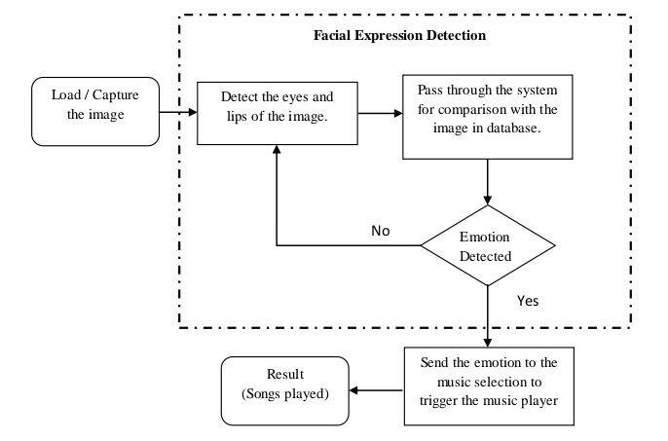
Figure2.2.1The flow chart of the proposed model
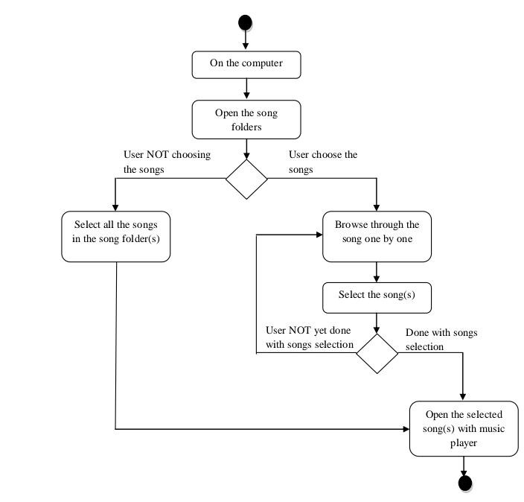
Figure2.2.2 The As-Is user process Flowchart

2.2.1 ADVANTAGES
- Plays music based on your mood
- No need to choose songs manually
- Changes songs if your mood changes
- Fun and smart way to listen to music
- Helps you feel better by matching your emotions
- Uses your face to understand how you feel
- Easy to use – just look at the camera
- Cool project using Python and web design

2.3 SYSTEM REQUIREMENT AND SPECIFICATION

2.3.1 HARDWARE REQUIREMENTS
This section gives the details and specification of the hardware on which the system expected to work.
Processor (CPU) : Intel Core i5/i7
RAM : Minimum 4GB or 8GB
Hard Disk : 256GB SSD Minimum
Keyboard : wireless keyboard
Monitor : 21-inch Full HD
Storage : 500 MB
Webcam : capture real-time video for emotion detection
Audio Output : Speaker / Headphones

2.3.2 SOFTWARE REQUIREMENTS
This section gives the details of the software that are used for the development.
- Frontend : HTML, CSS, JAVASCRIPT
- Backend : PYTHON
- Operating system : Windows, Linux, or mac OC
- Libraries : Open CV, DeepFace, numpy, pygame,threading
- Music playbacks : pygame.mixer(used to load and play audio files)
- Video streaming : open cv with flask
- Emotion detection : Deepface
- Face detection : Haar Cascades
- Browser : Chrome, Firefoc, or edge(performance UI)

2.3.3 ABOUT THE SOFTWARE
1. FRONTEND

HTML
An Emotion-Based Music Player using Face Detection and HTML is a smart application that detects a user's facial expressions to determine their emotional state and plays music that aligns with or enhances their mood. This system uses a webcam to capture the user's face and employs facial recognition algorithms to analyze emotions such as joy, sadness, anger, or surprise. HTML (HyperText Markup Language) is used to structure the layout of the music player, including elements like buttons, video input, and music controls. The integration of HTML provides the foundational framework for the user interface, making it accessible and easy to interact with through a web browser. This combination of emotion detection and web technology offers a personalized and interactive music experience.
HTML TAGS USED:
1.<!DOCTYPE html>
Syntax: <!DOCTYPE html>
Description: Declares the document type and version of HTML being used.
2.<html>
Syntax: <html>…</html>
Description: The root element of an HTML page. All other elements must be inside this element.
3.<head>
Syntax:<head> ... </head>
Description: Contains metadata, title, links to scripts, styles, and other head elements.
4.<title>
Syntax:<title>…</title>
Description: Defines the title of the document shown in the browser's title bar or tab.
5.<meta>
Syntax:<meta>…</meta>
Description: Provides metadata about the HTML document, such as character set, viewport settings, etc.
6.<script>
Syntax: <script>…</script>
Description: Embeds or references JavaScript code.
7. <div>
Syntax: <div>…</div>
Description: Defines a division or section in an HTML document, used to group block-level content.
8.<button>
Syntax: <button>...</button>
Description: Represents a clickable button used to submit forms or trigger events.
9.<img>
Syntax: <img>...</img>
Description: Embeds an image in the document.
- <p>
Syntax:<p>…</p>
Description: Defines a paragraph.
- <a>
Syntax:<a> href =”url’’…</a>
Description: Defines a hyperlink to another document or resource.
12.<footer>
Syntax:<footer>…</footer>
Description: The <footer> tag can appear multiple times in a document.

CSS
An Emotion-Based Music Player using Face Detection and CSS is an innovative system that automatically selects and plays music tracks based on a user's emotional state detected through facial expressions. By utilizing computer vision techniques and facial recognition algorithms, the system identifies emotions such as happiness, sadness, anger, or surprise from the user's face. Once the emotion is detected, the music player adjusts the playlist accordingly to match or improve the user's mood. CSS (Cascading Style Sheets) is used to design and style the user interface, ensuring a visually appealing and responsive layout. This technology combines artificial intelligence with front-end development to offer a personalized and emotionally intuitive listening experience.
CSS TAG USED:
.container
Sets a max width for the page content and centers it with padding.
.content
Description: defines a flexible layout for child elements, allowing wrap and spacing.

.Video-container
Description:Styles the face detection block-white background, padding rounded corners. .Music -container
Description: same as video container, but for the music player section.
.emotion-display
Description: Styles the detected emotion text-large font, centered, light background.
.controls
Description: Arranges control buttons vertically with space between them.
.song-info
Description: Displays the current song
.music-controls
Description: Styles a sub-section for the music controls.

Margin
Syntax: margin: 10px;
Description: sets the margin area on all four sides of an element.

Padding
Syntax: padding: 10px;
Description: sets the padding area on all four sides of an element.

Width
Syntax: width: 100%;
Description: sets the width of an element.

Height
Syntax: height: 50px;
Description: sets the height of an element

Border
Syntax: border: 1px solid #000;
Description: sets the border around an element.

Display
Syntax: display: block;
Description: specifies the display behavior of an element.

Text-align
Syntax: text-align: center;
Description: sets the horizontal alignment of text.

JAVASCRIPT
An emotion-based music player using face detection in JavaScript is a smart application that captures a user's facial expressions using their webcam and plays music that matches their mood. The process begins with accessing the webcam through the browser using the navigator.mediaDevices.getUserMedia() API. For detecting emotions, a popular library like face-api.js is used, which provides pre-trained models to recognize facial expressions such as happiness, sadness, anger, and surprise. Once the webcam feed is active, the script continuously scans the face in real time, detects the dominant emotion, and then maps it to a suitable music track using predefined logic in JavaScript.
For example, if the user looks sad, a calm or uplifting song might play, while a happy face might trigger a cheerful tune. The music is played using the HTML5 <audio> element or the Audio object in JavaScript. This type of system combines computer vision and user experience design to create interactive, emotion-aware web applications.
JAVASCRIPT USED:

Function
Syntax: function myfunction() { ... }
Description: defines a function in javascript

Document. getelementbyid
Syntax: document. getelementbyid("id")
Description: selects an html element by its id.

Var
Syntax: var x = 5;
Description: declares a variable.

If...else
Syntax: if (condition) { ...} else { ... }
Description: executes a block of code if a specified condition is true; otherwise, another block of code is executed.

For
Syntax: for (let i = 0; i < 5; i++) { ...}
Description: creates a loop that is executed as long as a condition is true.

Console.log
Syntax: console.log(message);
Description: prints a message to the web console.

Alert
Syntax: alert("message");
Description: displays an alert box with a specified message.

Settimeout
Syntax: settimeout(function, milliseconds);
Description: calls a function after a specified number of milliseconds.

.Json.parse
Syntax: json.parse(text);
Description: parses a json string and returns a javascript object.

Document.createelement
Syntax: document.createelement("div");
Description: creates an html element.

Element.innerhtml
Syntax: element.innerhtml = "content";
Description: sets or gets the html content of an element.

Element.style
Syntax: element.style.color = "red";
Description: sets the style of an element.

Return
Syntax: return value;
Description: exits a function and returns a value.

Switch
Syntax: switch(expression) { case x: ... Break; case y: ... Break; default:}
Description: evaluates an expression, matching the expression’s value to a case clause, and executes statements associated with that case.
2.BACKEND

PYTHON

1. Flask Setup
Syntax: app = Flask(_name_)
Description: template() serves HTML. Response() streams video.
jsonify() sends JSON to frontend.

2. Music Initialization
Syntax: pygame.mixer.init()
Description: Initializes Pygame’s audio mixer for music playback.

3. Playlists
Syntax: music_playlists = {
'happy': ['happy_song1.mp3', 'happy_song2.mp3'],
}
Description:A dictionary mapping each emotion to a list of songs
4. Global Variables current_emotion = None frame_lock = threading.Lock() current_frame = None
Description: Shared variables for syncing emotion and frame data across threads.

5. Face Detection Model
Syntax: face_cascade = cv2.CascadeClassifier(...)
Description: Loads a pre-trained face detection model using OpenCV.

6. Function: play_music()
Syntax: def play_music(emotion):
Description: Randomly selects and plays a song based on detected emotion.
Uses pygame.mixer.music.load() and .play().

7. Function: detect_emotion()
Syntaxt: def detect_emotion():
Description: Captures video from webcam,Detects faces using OpenCV.
Analyzes faces using DeepFace.analyze() to detect emotions.
Updates global current_emotion and current_frame.

8. Function: generate_frames()
Syntax: def generate_frames():
Description: Generates video frames encoded in JPEG, Used to stream video to browser.
9. Flask Routes Syntax: @app.route('/') def index(): return render_template('index.html')
Description: Serves the frontend HTML interface.
@app.route('/video_feed')
def video_feed(): return Response(generate_frames(), ...)
Streams live webcam feed to the browser.
@app.route('/get_emotion') def get_emotion(): return jsonify({'emotion': current_emotion})
Sends current detected emotion to the frontend in JSON format.
('/play_music/<emotion>') def play_music_route(emotion):
API endpoint to trigger music playback manually.

10. Run Flask + Emotion Detection Thread
Syntax:
if _name_ == '_main_':
detection_thread = threading.Thread(target=detect_emotion) detection_thread.daemon = True detection_thread.start() app.run(host='0.0.0.0', port=5000, threaded=True)
Description: Starts a background thread for emotion detection, Runs the Flask app on port 5000.

SYSTEM ANALYSIS AND DEVELOPMENT

SYSTEM ANALYSIS

3.1 System Flow Diagram
System Analysis is the structured process of examining the components, requirements, and operations of a system to ensure it effectively solves a specific problem. In the case of the Emotion-Based Music Player using Face Detection, system analysis involves identifying how the system should function — from capturing real-time facial expressions using a webcam, analyzing those expressions with emotion detection algorithms (e.g., using Python and OpenCV), to mapping the detected emotion to an appropriate music selection. It also includes assessing the integration between frontend technologies (HTML, CSS, JavaScript) and backend processes (Python), ensuring smooth communication, performance efficiency, and a user-friendly interface. This analysis is essential for defining the system's objectives, determining its feasibility, and guiding its design and development stages.
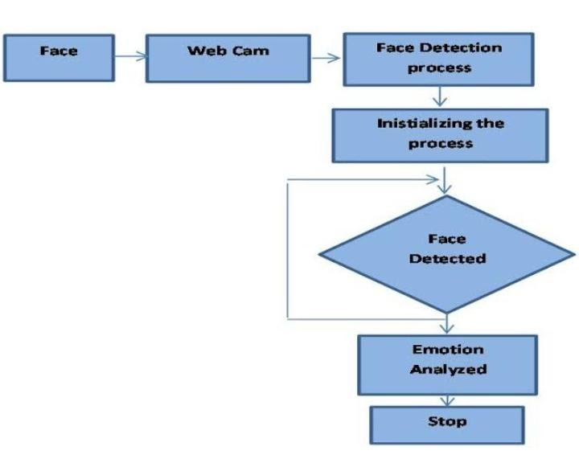

Figure3.1.1 System flow module

1.Webcam
The user's face is captured through the computer's webcam or a connected camera.
- Image Processing (Backend):
Face Detection: Python code, likely using libraries like OpenCV, detects and isolates the user's face in the captured image.
Emotion Recognition: Machine learning models, trained on datasets of facial expressions, analyze facial landmarks (e.g., eyes, mouth) to identify the user's emotional state (e.g., happy, sad, angry).
- Data Transfer (Backend to Frontend):
The detected emotion and potentially other relevant data (e.g., confidence score) are sent from the Python backend to the HTML/JavaScript frontend.
- Frontend Display and Music Selection:
UI Update: The frontend displays the identified emotion and potentially provides a visual representation of the detected mood.
Music Playlist Creation: Based on the detected emotion, the frontend selects a playlist of songs that either match the user's mood or are designed to influence their emotional state.
- Music Playback:
The choose music playlist is played using the files built-in audio player.
JavaScript-based music player library.

3.2 DATA FLOW DIAGRAM
The data flow in this system begins when the user opens the application, and their webcam captures a live image of their face. This image is sent to the Python backend, which uses a pre-trained emotion detection model to analyze facial expressions and determine the user's current emotion (such as happy, sad, angry, or relaxed). Once the emotion is identified, the system refers to a music database or emotion-to-song mapping that links specific emotions with matching genres or playlists. Based on this mapping, the system selects a suitable song or playlist and sends it to the front-end music player, which plays the audio for the user. This system creates a personalized experience by dynamically adapting music selection to the user's mood, making use of real-time image processing, machine learning, and web technologies. The data flow diagram (DFD) helps visualize this interaction between user inputs, processing logic, and outputs, clarifying how data moves through different components of the application.
HTML: Used for creating the structure and layout of the web page (e.g., playlist display, webcam preview).
CSS: Used for styling and formatting the web page, making it visually appealing and userfriendly.
JavaScript: Used for handling user interactions (e.g., webcam access, sending data to Python), managing the playlist, and playing music.
Python: Used for the backend logic, including face detection, emotion recognition, and data processing.
Webcam: Used to capture the user's facial expressions.
Face Detection/Emotion Recognition Libraries: Libraries like OpenCV, TensorFlow, and PyTorch are used for facial expression recognition.
Music Player Libraries: play sound,pygame, audio API for playing music in the stream audio in real time.
**
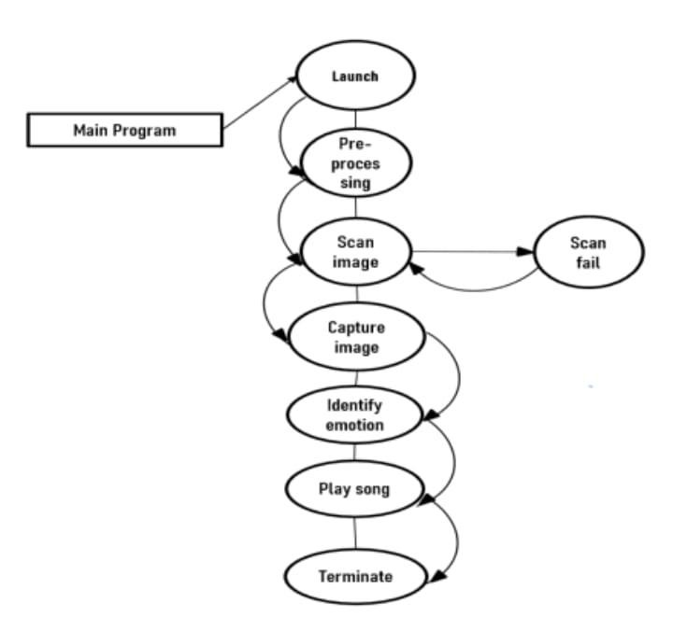
Figure3.2.1 data flow module
SYSTEM TESTING RESULT
Functionality testing is done once the completion of the system development. The completion of the system development. The purpose is to check if the model is usable and well-functioned.
The results are shown as table below.

Component | Expected Function | Testing Result
“Browse” button | Direct user to the local disk and select image.
Webcam “start”button | Start the embedded webcam / external  webcam
“Start”button | To start the image analysis process once it is pressed,
“Restart”button | Stop the currently played songs
“Setting”button | Enable user to customize the songs for each emotion.
“Exit” button | Close the window of the proposed model
- System functional testing results

3.3 MODULE DESCRIPTION
- Face detection module
- Emotion Recognition
- Music Mapping Module
- Music Player Module
- User interface Module
- Data Logging and Analytics Module

1. Face Detection Module
Capturing and Locating Facial Features in Real-Time
This module is responsible for detecting the user’s face using a webcam or uploaded image. It utilizes computer vision techniques such as Haar Cascades, Dlib, or MTCNN to locate the facial region. The detected face is then cropped and prepared as input for the emotion recognition module. Accurate face detection is critical as it directly influences the accuracy of emotion classification.

2. Emotion Recognition Module
Identifying User Emotions Through Facial Expressions
Once the face is detected, this module analyzes the facial expressions to determine the user’s current emotional state. It uses deep learning models, typically Convolutional Neural Networks (CNNs), trained on emotion datasets like FER2013. The model classifies emotions such as Happy, Sad, Angry, Neutral, and more, based on subtle facial features.

3. Music Mapping Module
Linking Emotions to Personalized Music Categories
This module takes the detected emotion and maps it to a corresponding music category. For example, a "Happy" emotion might be linked to upbeat pop music, while "Sad" may connect to slow acoustic tracks. A predefined mapping table or rule-based logic is used to match emotions with appropriate playlists or genres to ensure a personalized music experience.

4. Music Player Module
Seamless Playback of Emotion-Driven Music
The music player module handles playback functionality, including playing, pausing, and skipping songs. Based on the emotion mapped in the previous module, it retrieves and plays the corresponding music from local storage or an online streaming service. It ensures a smooth listening experience tailored to the user's mood.

5. User Interface Module
User-Friendly Interface for Interaction and Control
This module provides an intuitive interface where users can view the detected emotion and the currently playing song. It may also display the live camera feed and offer manual controls to override emotion detection or music selection. The interface can be developed as a desktop app using Tkinter or PyQt, or as a web app using Flask or React.

6. Data Logging and Analytics Module (Optional)
Recording Emotional Trends and Usage Patterns
This optional module logs user interactions, detected emotions, and music preferences over time. It can be used to generate insights, such as the most common mood of the user or frequently played genres. These analytics can help improve emotion detection accuracy and refine future music recommendation.

3.4 INPUT DESIGN
The main objective of designing the input for an emotion-based music player using face detection is to enable the system to automatically recognize and interpret the user's emotional state through facial expressions captured by a camera. This allows the music player to personalize the listening experience without requiring manual input. The input design ensures real-time, accurate emotion detection by incorporating facial recognition, image preprocessing, and emotion classification techniques. It aims to create a seamless, user-friendly, and adaptive system that selects music based on the user's mood, enhancing emotional engagement and satisfaction.
The main objective of designing input focus on:
- Automatic Emotion Recognition:
To detect the user’s emotional state through facial expressions without manual input.
- Real-Time Processing:
To capture and analyze facial data instantly for immediate music suggestions.
- High Accuracy:
To ensure reliable emotion detection through advanced face recognition and classification techniques.
- User-Friendly Interface:
To design a seamless and non-intrusive input system using a camera.
- Emotion-Music Mapping:
To link detected emotions with suitable music genres or playlists for mood-based recommendations.
- Adaptability:
To function effectively across different lighting conditions, facial orientations, and user environments.
- Privacy and Security:
To ensure user facial data is processed securely and ethically.

3.5 OUTPUT DESIGN
The emotional-based music player is a smart application that detects the user's facial expression through their webcam and plays music based on their current emotional state. The system is built using a combination of front-end and back-end technologies. The front-end (HTML, CSS, JavaScript) presents a user interface with a video feed, a button to trigger emotion detection, and a music player. When the user clicks the "Detect Emotion" button, the JavaScript captures an image frame from the webcam and sends it to the Python back-end using a POST request. The Python server uses a facial emotion detection model (such as DeepFace or FER) to analyze the image and determine the dominant emotion. Based on this detected emotion, the server responds with a music file URL, and the front-end then plays a matching song. The CSS enhances the appearance of the player, making the interface user-friendly and visually appealing.
Frontend (HTML/CSS/JavaScript):
HTML structures the music player interface (video stream, button, music player).
CSS styles the interface with a clean, modern look.
JavaScript accesses the webcam, captures a frame, and sends it to the back-end via fetch API.
Receives detected emotion and music URL from the server and plays the song.
Backend (Python with Flask):
Receives the image from the frontend.
Decodes the image and applies face detection and emotion analysis (e.g., using DeepFace.
Maps the detected emotion (e.g., happy, sad, angry) to a predefined song.
Sends the emotion and corresponding music file URL back to the frontend.
Emotion Detection:
Utilizes libraries like DeepFace or FER for real-time emotion recognition.
Supports emotions like happy, sad, angry, neutral, surprised, etc.
Music Selection:
Each emotion is linked to a song or playlist stored on the server.
Songs are returned dynamically based on detected emotion.
Example Emotions and Songs:
- Happy → Upbeat pop song.
- Sad → Calm or instrumental track.
- Angry → Rock or intense instrumental.
- Neutral → Chill or ambient background music.
Real-Time Emotion Detection: Uses webcam input and a Python-based model to detect emotions like happy, sad, angry, or neutral in real time.
Dynamic Music Playback: Automatically selects and plays a music track based on the detected emotion to match the user's mood.
Integrated Technologies: Combines Python for backend processing with HTML, CSS, and JavaScript for a responsive, interactive web-based user interface.

3.6 DATABASE DESIGN
- Tabel name: Users
Purpose: Stores information about the users.

Column name | Data type | Description
Id | INT | Primary key, Auto Increment.
user name | VARCHAR(15) | User`s username
Email | VARCHAR(10) | User`s emails
Created_at | DATETIME | Timestamp of account creation.
Updated_at | DATETIME | Timestamp of last account update

- Tabel name: Emotions
Purpose: Stores information about emotions that the system detects

Column name | Data type | Description
Emotion_id | INT | Unique emotion ID
Name | VARCHAR(15) | Emotion name(e.g.,happy, sad)
Description | TEXT | Optional description

- Tabel name: Songs
Purpose: Maps songs to specific emotions.
Column name | Data type | Description
Id | INT | Unique identifier for each song
Title | VARCHAR(25) | Title of the song
Artist | VARCHAR(18) | Artist or creator
File_path | VARCHAR(20) | Local path or URL to the music file
Emotion_id | INT | Emotion associated with the song
Duration | INT | Duration in seconds

- Tabel name: playback_history
Purpose: Logs song playback data tied to emotion detection.
Column name | Data type | Description
History_id | INT | Unique playback history id
Song_id | INT | Song that was played
Emotion_id | INT | Emotion during playback
Played_at | DATETIME | Timestamp of playback
Detected_at | DATETIME | Time of detection

- Tabel name: user table
Purpose: if you plan to add multi-user support:
Column name | Data type | Description
Id | INT | Unique user ID
Username | VARCHAR(15) | User name
Email | VARCHAR(10) | Email
Password | VARCHAR(50) | Hashed password
Created_at | DATETIME | Account creation time stamp

3.7 CODE DESIGN
<!-- templates/index.html -->
<!DOCTYPE html>
<html lang="en">
<head>
<meta charset="UTF-8">
<meta name="viewport" content="width=device-width, initial-scale=1.0">
<title>Emotion-Based Music Player</title>
<style> body {
font-family: 'Arial', sans-serif; margin: 0; padding: 0;
background-color: #f5f5f5; color: #333;
}

.container { max-width: 1200px; margin: 0 auto; padding: 20px;
}

header {
background-color: #1DB954;
color: white;
padding: 20px 0; text-align: center; border-radius: 8px; margin-bottom: 30px;
}
h1 { margin: 0; font-size: 2.5em;
}

.content { display: flex; flex-wrap: wrap; gap: 30px; justify-content: center;
}

.video-container { flex: 1; min-width: 400px; background-color: #fff; border-radius: 8px; box-shadow: 0 4px 8px rgba(0, 0, 0, 0.1); padding: 20px;
}

.music-container { flex: 1; min-width: 400px; background-color: #fff; border-radius: 8px; box-shadow: 0 4px 8px rgba(0, 0, 0, 0.1); padding: 20px;
}

video { width: 100%; border-radius: 4px; background-color: #000;
}

.emotion-display { font-size: 2em; text-align: center; margin: 20px 0; padding: 15px; border-radius: 8px; background-color: #f0f0f0;
}

.controls { display: flex; flex-direction: column; gap: 15px;
}

button { background-color: #1DB954; color: white; border: none; padding: 12px 20px; border-radius: 4px; cursor: pointer; font-size: 1em; transition: background-color 0.3s;
}

button:hover {
background-color: #1ed760;
}

.song-info { margin-top: 20px; padding: 15px; background-color: #f0f0f0; border-radius: 8px;
}

footer { text-align: center; margin-top: 30px; padding: 20px; color: #666;
}

@media (max-width: 768px) {
.content { flex-direction: column;
}

.video-container, .music-container { min-width: 100%;
}
}
</style>
</head>
<body>
<div class="container">
<header>
<h1>Emotion-Based Music Player</h1>
<p>Let your emotions guide your music experience</p> </header>

<div class="content">
<div class="video-container">
<h2>Face Detection</h2>
<img id="videoFeed" src="{{ url_for('video_feed') }}" alt="Video Feed">
<div class="music-controls">
<h2>Music Controls</h2>
<p>Detected emotion will trigger music playback.</p>
<audio id="audio-player" controls autoplay></audio>
</div>
</div>

<div class="music-container">
<h2>Music Player</h2>
<div class="emotion-display" id="emotionDisplay"> Detecting emotion...
</div>

<div class="controls">
<button id="autoPlayBtn">Enable Auto-Play</button>
<button id="playHappy">Play Happy Song</button>
<button id="playSad">Play Sad Song</button>
<button id="playAngry">Play Angry Song</button>
<button id="playNeutral">Play Neutral Song</button>
</div>

<div class="song-info" id="songInfo">
No song currently playing
</div>
</div>
</div>

<footer>
<p>Emotion-Based Music Player &copy; 2023</p>
</footer>
</div>

<script>
// Global variables let autoPlayEnabled = false; let lastEmotion = null;

// DOM elements
const emotionDisplay = document.getElementById('emotionDisplay'); const autoPlayBtn = document.getElementById('autoPlayBtn'); const playHappyBtn = document.getElementById('playHappy'); const playSadBtn = document.getElementById('playSad'); const playAngryBtn = document.getElementById('playAngry'); const playNeutralBtn = document.getElementById('playNeutral'); const songInfo = document.getElementById('songInfo');

// Event listeners
autoPlayBtn.addEventListener('click', toggleAutoPlay);
playHappyBtn.addEventListener('click', () => playManualSong('happy')); playSadBtn.addEventListener('click', () => playManualSong('sad')); playAngryBtn.addEventListener('click', () => playManualSong('angry')); playNeutralBtn.addEventListener('click', () => playManualSong('neutral'));

// Function to toggle auto-play function toggleAutoPlay() { autoPlayEnabled = !autoPlayEnabled;
autoPlayBtn.textContent = autoPlayEnabled ? 'Disable Auto-Play' : 'Enable AutoPlay'; autoPlayBtn.style.backgroundColor = autoPlayEnabled ? '#ff4d4d' : '#1DB954';

if (autoPlayEnabled) { checkEmotion();
}
}

// Function to manually play a song function playManualSong(emotion) { fetch(/play_music/${emotion})
.then(response => response.json())
.then(data => {
songInfo.textContent = Playing ${emotion} song...;
})
.catch(error => {
console.error('Error:', error);
songInfo.textContent = 'Error playing song';
});
}

// Function to check emotion periodically function checkEmotion() { if (!autoPlayEnabled) return;

fetch('/get_emotion')
.then(response => response.json())
.then(data => {
const emotion = data.emotion;

if (emotion) {
emotionDisplay.textContent = Detected Emotion: ${emotion}; emotionDisplay.style.color = getEmotionColor(emotion);

// Only play if emotion changed if (emotion !== lastEmotion) { lastEmotion = emotion; playManualSong(emotion);
}
} else {
emotionDisplay.textContent = 'No face detected'; emotionDisplay.style.color = '#333';
}

// Check again after 2 seconds setTimeout(checkEmotion, 2000);
})
.catch(error => { console.error('Error:', error); setTimeout(checkEmotion, 2000);
});
}

// Helper function to get color based on emotion function getEmotionColor(emotion) { const colors = {
'happy': '#1DB954',
'sad': '#3498db',
'angry': '#e74c3c',
'surprise': '#f39c12',
'neutral': '#9b59b6',
'fear': '#2ecc71',
'disgust': '#e67e22'
};

return colors[emotion.toLowerCase()] || '#333';
}
</script>
</body>
</html>
# app.py
"from flask import Flask, render_template, Response, jsonify" import cv2
import numpy as np from deepface import DeepFace import pygame import random import time import threading

app = Flask(_name_)

# Initialize pygame for music playback pygame.mixer.init()

# Define music playlists based on emotions music_playlists = {
" 'happy': ['happy_song1.mp3', 'happy_song2.mp3'],"
" 'sad': ['sad_song1.mp3', 'sad_song2.mp3'],"
" 'angry': ['angry_song1.mp3', 'angry_song2.mp3'],"
" 'surprise': ['surprise_song1.mp3', 'surprise_song2.mp3'],"
" 'neutral': ['neutral_song1.mp3', 'neutral_song2.mp3'],"
" 'fear': ['fear_song1.mp3', 'fear_song2.mp3'],"
" 'disgust': ['disgust_song1.mp3', 'disgust_song2.mp3'],"
}

# Global variables for sharing data between threads current_emotion = None frame_lock = threading.Lock() current_frame = None

# Load OpenCV face detector
face_cascade = cv2.CascadeClassifier(cv2.data.haarcascades +
"haarcascade_frontalface_default.xml")

def play_music(emotion):
"""Function to play a random song from the playlist"""
if emotion in music_playlists:
song = random.choice(music_playlists[emotion]) try:
pygame.mixer.music.load(song) pygame.mixer.music.play()
print(f"Playing {song} for emotion: {emotion}") return True except Exception as e:
print(f"Error playing song: {e}") return False else:
print(f"No playlist found for emotion: {emotion}") return False

def detect_emotion():
"""Thread function for continuous emotion detection"""
" global current_emotion, current_frame"

cap = cv2.VideoCapture(0)

while True:
" ret, frame = cap.read()" if not ret: continue

" gray = cv2.cvtColor(frame, cv2.COLOR_BGR2GRAY)"
" faces = face_cascade.detectMultiScale(gray, scaleFactor=1.3, minNeighbors=5, minSize=(50, 50))"

emotion = None
" for (x, y, w, h) in faces:"
" face = frame[y:y + h, x:x + w]"
try: " analysis = DeepFace.analyze(face, actions=['emotion'], enforce_detection=False)" emotion = analysis[0]['dominant_emotion']

" cv2.rectangle(frame, (x, y), (x + w, y + h), (0, 255, 0), 2)"
" cv2.putText(frame, emotion, (x, y - 10), cv2.FONT_HERSHEY_SIMPLEX, 0.8, (0, 255, 0), 2)"

except Exception as e: print(f"Error: {e}")

with frame_lock:
current_emotion = emotion
" _, buffer = cv2.imencode('.jpg', frame)" current_frame = buffer.tobytes()

time.sleep(0.1)

cap.release()

def generate_frames():
"""Generator function for video streaming""" while True: with frame_lock: if current_frame is None: continue frame = current_frame yield (b'--frame\r\n'
b'Content-Type: image/jpeg\r\n\r\n' + frame + b'\r\n')

@app.route('/') def index(): return render_template('index.html')

@app.route('/video_feed')
def video_feed():
" return Response(generate_frames(), mimetype='multipart/x-mixed-replace; boundary=frame')"

@app.route('/get_emotion') def get_emotion(): global current_emotion
return jsonify({'emotion': current_emotion})

@app.route('/play_music/<emotion>') def play_music_route(emotion): success = play_music(emotion)
return jsonify({'status': 'success' if success else 'error'})

if _name_ == '_main_':
# Start the emotion detection thread
detection_thread = threading.Thread(target=detect_emotion) detection_thread.daemon = True detection_thread.start()

# Run the Flask app
" app.run(host='0.0.0.0', port=5000, threaded=True)"

3.8 REPORT DESIGN

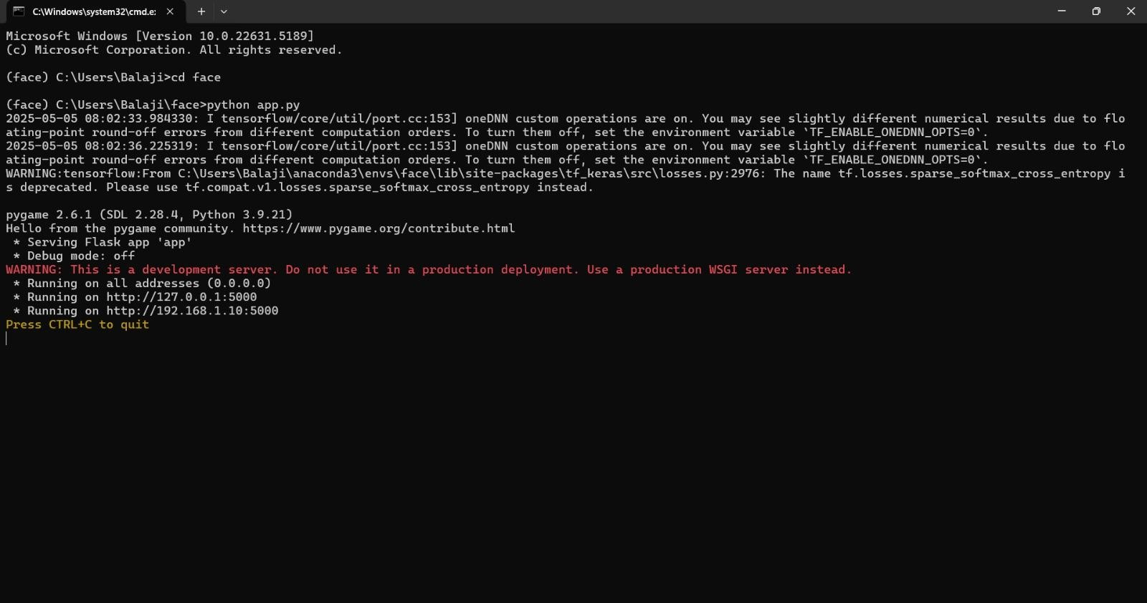
figure3.8.1command prompt

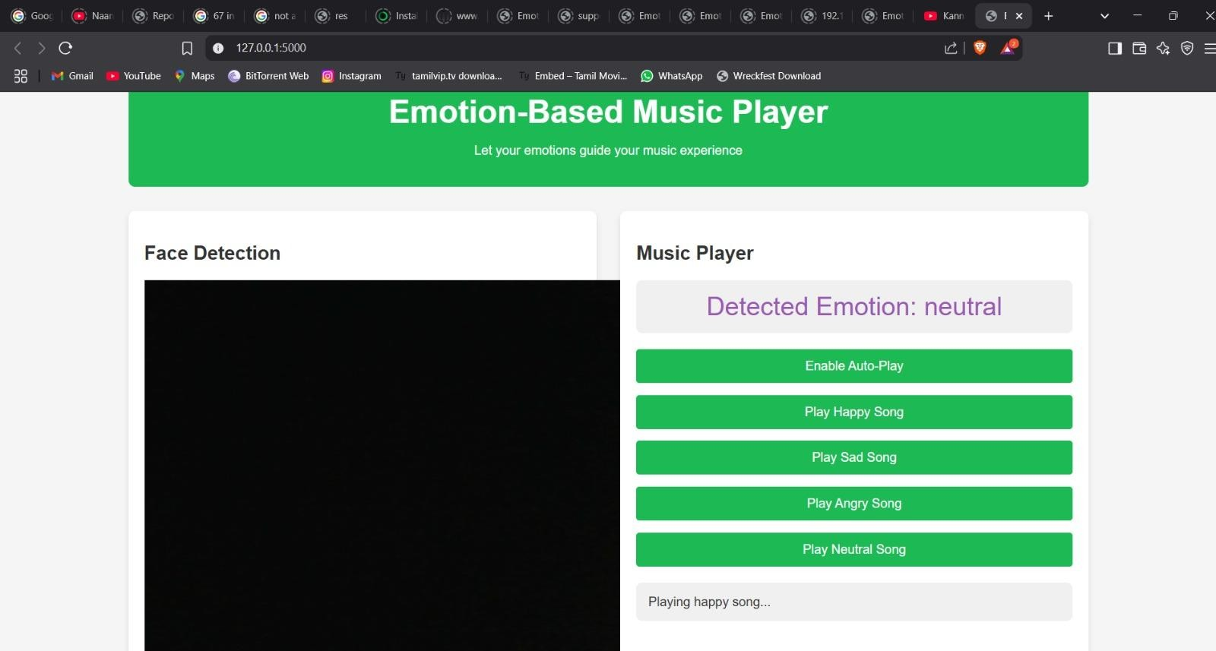
Figure3.8.2face detection module

TESTING AND IMPLEMENTATION

4.TESTING AND IMPLEMENTATION

4.1 SYSTEM TESTING
The system analysis of an emotion-based music player using face detection focuses on understanding how the system functions, its key components, and its objectives. This intelligent system is designed to detect a user's emotional state by analyzing facial expressions captured through a webcam or camera. Once the emotion is identified—such as happiness, sadness, anger, or neutrality—the system automatically selects and plays music that matches the detected mood. It integrates computer vision for face detection, machine learning or deep learning for emotion classification, and a music playback or recommendation system, which may rely on local files or online music platforms like Spotify.
The system requires both hardware components (such as a camera and speakers) and software tools (including Python libraries like OpenCV, DeepFace). Functionally, the system should be able to detect faces, recognize emotions accurately in real time, and trigger the appropriate playlist without user intervention. Non-functional aspects such as responsiveness, accuracy, user-friendliness, and system performance are equally critical to ensure a seamless user experience. The goal is to create a smart, emotionally aware application that enhances the user’s mood and provides personalized music experiences based on facial cues.
SYSTEM TESTING RESULTS
Functionality testing is done once the completion of the system development. The completion of the system development. The purpose is to check if the model is usable and well-functioned.
The results are shown as table below.
Component | Expected Function | Testing Result
“Browse” button | Direct user to the local disk and select image.
Webcam “start”button | Start the embedded webcam / external  webcam
Webcam “start”button | Start the embedded webcam / external  webcam
“Start”button | To start the image analysis process once it is pressed,
“Restart”button | Stop the currently played songs
“Setting”button | Enable user to customize the songs for each emotion.
“Exit” button | Close the window of the proposed model

1. Functional Testing
This stage ensures that the core features of face detection and emotion classification are working correctly. The system should accurately identify faces and distinguish between different emotions such as happiness, sadness, anger, surprise, and neutrality. Testing should be done using varied facial expressions, lighting conditions, and camera angles to ensure robustness.

2. Performance Testing
The system’s responsiveness is crucial for user satisfaction. The time taken from detecting a face to playing the appropriate music should be minimal, ideally under 3 seconds. Performance tests should also assess the system's efficiency under continuous use or when handling high-resolution input.

3. Usability Testing
Usability testing focuses on the user experience. Testers from different backgrounds should interact with the system to evaluate ease of use, user interface design, and whether the recommended music fits the detected emotion. Feedback can help refine the interface and emotion-music mapping.

4. Edge Case Testing
To ensure reliability, edge cases must be tested. This includes scenarios like multiple faces in the frame, faces with masks or glasses, partially visible faces, or no face at all. The system should respond appropriately, such as prompting for clearer input or ignoring unintended faces.

5. Integration Testing
This verifies that the emotion recognition system properly communicates with the music playback module or third-party APIs (e.g., Spotify). Smooth integration ensures a seamless user experience from emotion detection to music playback.

4.2 SYSTEM IMPLEMENTION
The implementation of an emotion-based music player using face detection involves several key steps. First, a webcam is used to capture the real-time image of the user's face. The system uses the OpenCV library to detect the face in the image. Once the face is detected, it is passed to an emotion recognition model built using machine learning libraries like TensorFlow or Keras. This model analyzes facial features and predicts the user's emotion, such as happy, sad, angry, or neutral. Based on the detected emotion, the system selects a song from predefined playlists that match the mood. For example, it plays energetic music when the user is happy or calm music when the user is sad.
The music is then played using a media player library like Pygame or VLC in Python. A simple graphical user interface (GUI) can also be added using to improve user interaction. This system creates a smart and personalized music experience by understanding the user's emotions through facial expressions.

CONCLUSION

5.CONCLUSION

5.1 CONCLUSION
The significant of this project is the emotion detection of the image loaded into the proposed model. The main purpose is emotion on detection functionally. Through the integration between emotion detection technology and music player, the proposed model is aimed to provided betterment in the individual entertainment. The system offers a personalized and intuitive way of interacting with music. Instead of manually selecting songs or playlists, users are provided with music that resonates with their current emotional state, making the listening experience more meaningful, immersive, and therapeutic.
This intelligent system combines real-time face detection, emotion classification, and music recommendation modules to create a seamless and responsive application. It uses tools such as OpenCV for face tracking and emotion recognition libraries like DeepFace or FER to identify emotions such as happiness, sadness, anger, and neutrality. Based on the detected emotion, the system plays music from either a local database or integrated platforms such as Spotify or YouTube, ensuring diversity and flexibility in music choice.
The benefits of this system go beyond convenience. It holds potential for use in mental health support, mood regulation, and stress relief. By adapting music to the user's emotions, it fosters a more emotionally aware and supportive digital environment. However, for the system to reach its full potential, it must be trained with diverse datasets to improve emotion accuracy and should be tested under varying real-world conditions, such as different lighting and facial orientations.
In conclusion, the emotion-based music player using face detection is a forwardthinking innovation that blends AI, emotion science, and entertainment. As machine learning models continue to improve, such systems will become more accurate, inclusive, and user-friendly. With ongoing development and ethical considerations for data privacy, this technology could redefine how users engage with music, making it not just a source of entertainment but a companion tuned to their emotions.

FUTURE ENHANCEMENT

6.FUTURE ENHANCEMENT

6.1 SCOPE FOR FUTURE ENHANCEMENT
Future enhancements of an emotion-based music player using face detection focus on several key areas to improve user experience. These include refining emotion recognition by incorporating multi-modal inputs like voice tone and heart rate, offering real-time adaptive music suggestions that adjust to shifting emotional states, and enabling multi-user detection for group settings. Integration with wearables and smart devices could provide more personalized experiences, while context-aware emotion recognition would tailor music based on factors like time of day or activity. Expanding platform support and adding accessibility features would ensure broader reach, and the system could have therapeutic applications to help manage stress or mental health. Ensuring robust privacy protections and user control over data would be crucial for trust and security. Overall, these advancements could transform the system into a highly personalized, emotionally intelligent tool that enhances both music enjoyment and emotional well-being.
- Improved Emotion Detection Accuracy: Incorporate advanced deep learning models and multi-modal inputs (e.g., voice tone, body language) for better emotion recognition.
- Real-Time Music Adaptation: Allow the system to continuously adjust the music playlist in real-time based on changing emotions throughout the day.
- Multi-User Support: Enable the system to recognize and adjust to the emotional states of multiple users in shared spaces, tailoring music for everyone.
- Integration with Wearables: Sync with wearables like smartwatches to track physiological indicators such as heart rate and stress levels, offering more personalized emotional responses.
- Contextual Music Recommendations: Use contextual data (e.g., time of day, location, activity) to improve the relevancy of music recommendations based on emotional context.

BIBLIOGRAPHY

7.BIBLIOGRAPHY

7.1 TEXT BOOK REFERENCES
- Szeliski, R. (2010). Computer Vision: Algorithms and Applications. Springer.
- Bishop, C. M. (2006). Pattern Recognition and Machine Learning. Springer.
- Russell, S. J., & Norvig, P. (2021). Artificial Intelligence: A Modern Approach (4th ed.).
Pearson.
- Goodfellow, I., Bengio, Y., & Courville, A. (2016). Deep Learning. MIT Press.
- O’Reilly, T. (2017). Flask Web Development: Developing Web Applications with Python. O'Reilly Media.
- Nixon, M., & Aguado, A. (2012). Feature Extraction and Image Processing for Computer Vision. Academic Press.
- Gonzalez, R. C., & Woods, R. E. (2018). Digital Image Processing (4th ed.). Pearson.
- Han, J., Kamber, M., & Pei, J. (2011). Data Mining: Concepts and Techniques (3rd ed.).
Morgan Kaufmann.

7.2WEBSITES REFERENCES
- Emotion Recognition using Deep Learning — GitHub Project https://github.com/omar178/Emotion-recognition
- Real-Time Face Detection with OpenCV — OpenCV Docs https://docs.opencv.org/4.x/d7/d00/tutorial_meanshift.html
- Web Audio API — MDN Web Docs https://developer.mozilla.org/en-US/docs/Web/API/Web_Audio_API
- Flask Official Documentation https://flask.palletsprojects.com/
- Deploying Python with HTML using Flask — GeeksforGeeks https://www.geeksforgeeks.org/python-create-a-music-player-using-tkinter/
- JavaScript Music Player Tutorial — freeCodeCamp https://www.freecodecamp.org/news/javascript-music-player-project/
- Real-time Emotion Detection using CNN — Medium https://medium.com/@datamonsters/real-time-emotion-recognition-from-video-usingcnn-4cbb7b7d90be

APPENDIX

8.APPENDIX

8.1 SCREEN LAYOUT
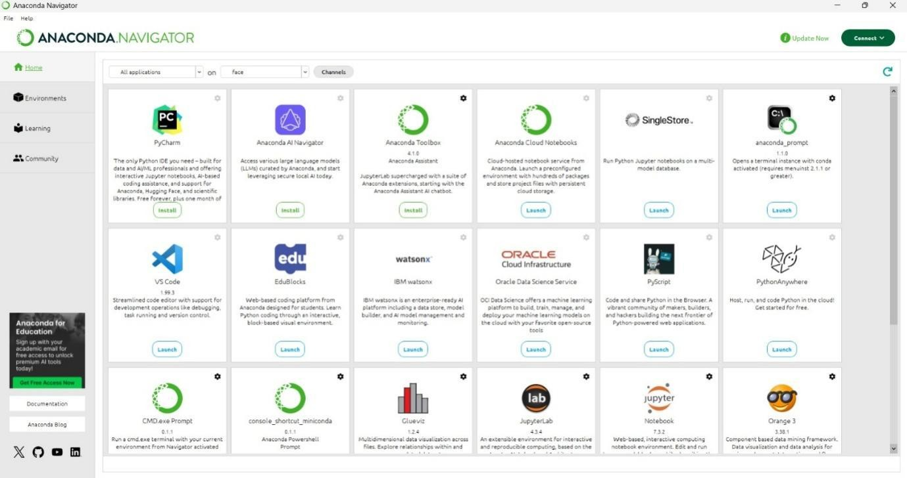
Figure 8.1 source navigator

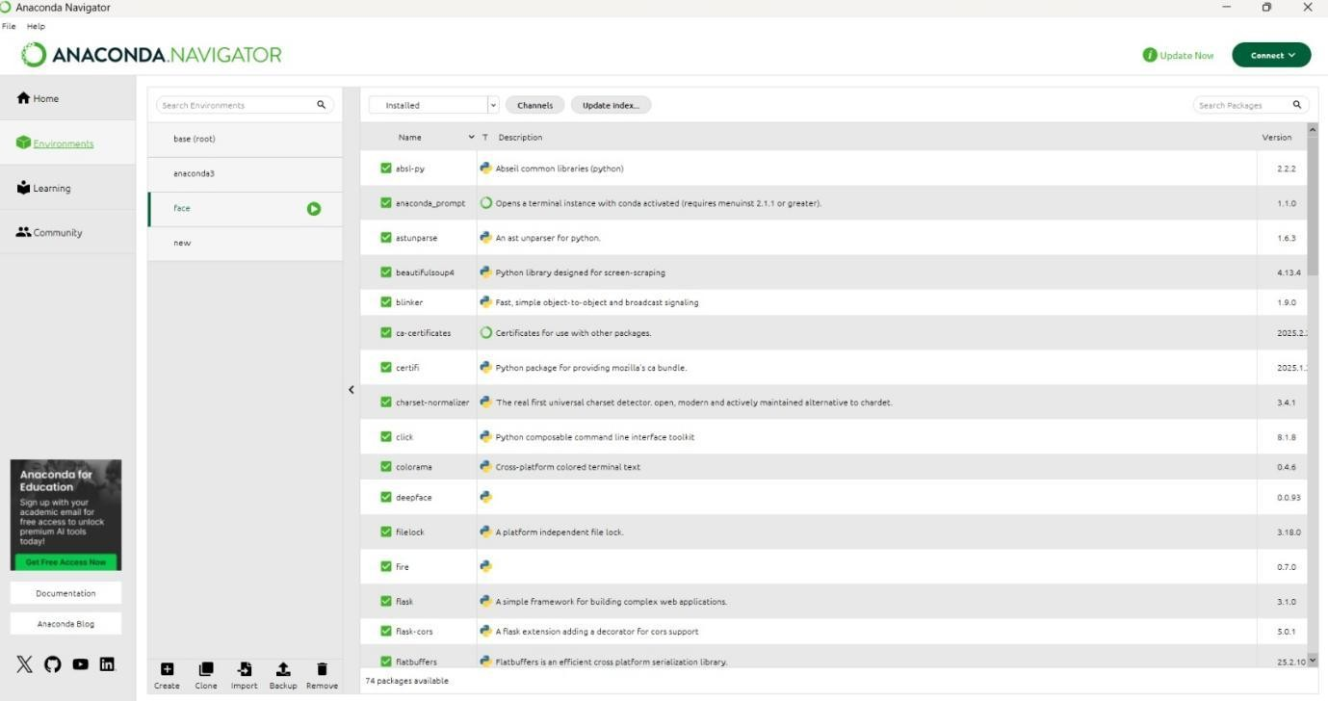
Figure 8.2 file module

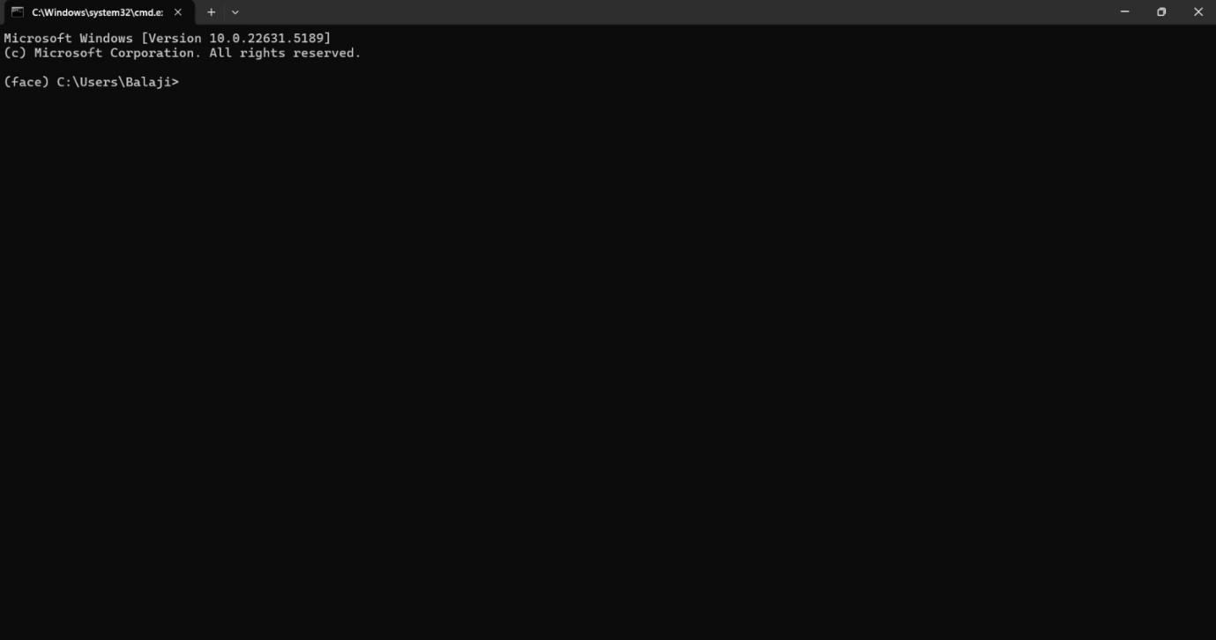
figure8.3 command prompt



Figure8.4 command run



Figure8.5 face detection module

